GIT (GLOBAL INFORMATION TRACKER) – Day -1 Date- 22/10/2025

Git - Git is used for source code management. It is a free and open-source version control system used to handle small to very large projects efficiently.
Git is used to track changes in the source code, to have a History of code and also can track who made the changes.
It is a distributed version control system (DVCS)
Source Code Management (SCM):
Source Code Management, also known as Version Control, is a system that helps developers track and manage changes to their software code.
It allows multiple developers to collaborate on a project by keeping a history of code changes, enabling easy rollback to previous versions, and facilitating teamwork without conflicts.
Version control system (VCS):
Version control systems are tools that help developers manage changes to their code over time. They allow developers to collaborate on projects, track changes to code, and revert to earlier versions of code if needed.
Ex: git, svn, clearcase, mercurial, tfs
Distributed Version Control System (DVCS):
A Distributed Version Control System is a type of VCS where every contributor has a complete copy of the project's entire history and can work independently. Git is a popular DVCS that enables decentralized collaboration and offline development.
Ex: git, bitbucket, cloudbees, aws, azure.
Centralized Version Control System (CVCS):
A Centralized Version Control System is a type of VCS where there is a single central repository that stores the project's history. Developers must connect to this central server to access and update the code. Older systems like Subversion (SVN) are examples of CVCS.
Ex: clearcase, svn
GitHub:
GitHub is a popular web-based platform for hosting and managing source code using Git, a distributed version control system (DVCS).
It provides tools for collaboration, such as issue tracking, pull requests, and code reviews, making it widely used by developers and teams for open-source and private projects.
Features of Git
- Tracks history
- Free and open source
- Supports non-linear development
- Creates backups
- Scalable
- Supports collaboration
- Branching is easier
- Distributed development

Benefits of using Git:
- Distributed Version Control: Git is a distributed version control system, which means that every developer has a local copy of the codebase. This allows developers to work offline and makes it easier to collaborate with others.
- Branching and Merging: Git makes it easy to create branches of code, which allows developers to work on features or fixes without affecting the main codebase. Git also makes it easy to merge changes from one branch to another.
- History and Tracking: Git tracks every change made to the codebase, including who made the change and when. This makes it easy to see the history of the codebase and to track down bugs or issues.
- Collaboration: Git makes it easy for multiple developers to collaborate on a project. Developers can work on different branches of the codebase and then merge their changes together.
What is a Git repository?
Git repository refers to a place where all the Git files are stored. These files can either be stored on the local repository or on the remote repository.

Local Repository: A local repository is a copy of a Git repository that is stored on your local machine. It contains all the files and the complete version history of the project.
You typically create a local repository when you start a new project or when you clone an existing remote repository to your local machine.
Remote Repository: A remote repository is a Git repository that is hosted on a remote server, which could be on the web or a network location.
GitHub, GitLab, and Bitbucket are examples of platforms that host remote repositories.

Git Installation on Different Platforms
The installation process for Git varies depending on the operating system you are using.
- Windows: To install Git on Windows, you can download the installer from the official Git website (https://git-scm.com/download/win). Once downloaded, run the installer, and follow the on-screen instructions.
- Mac: Git comes pre-installed on most Macs, but you can also download the installer from the official Git website (https://git-scm.com/download/mac). Once downloaded, run the installer, and follow the on-screen instructions.
- Linux: To install Git on Linux, you can use your distribution's package manager. For example, on Ubuntu, you can run the command "sudo apt-get install git" in the terminal to install Git.
- Check the version of git installed in your machines –> git --version
Task -
- Install Git
- Create Github account
- Create Github Public Repository
----------------------------------------------------------------------------------------------------------------------------------------------------------------
GIT (GLOBAL INFORMATION TRACKER) – Day -2 Date- 23/10/2025
Git Architecture
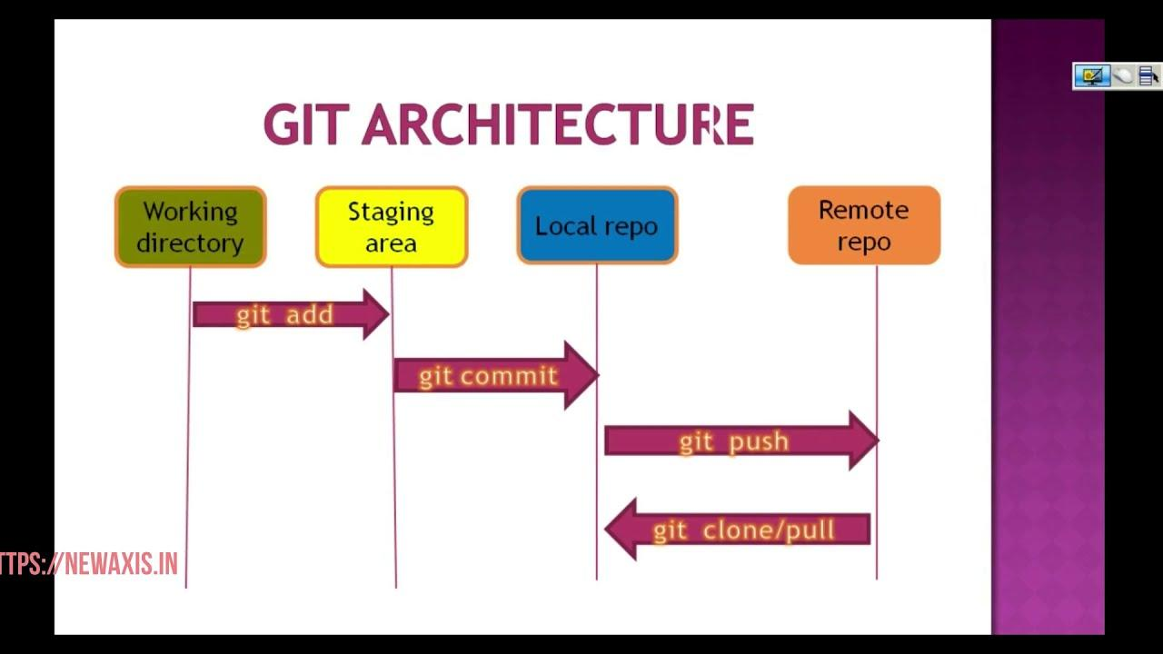

The Git architecture is divided into 4 main components: the working directory, the staging area, Local Repository, and Remote repository.
Working Directory: This is the directory where developers do their work. It contains the files and folders that make up the codebase.
Staging Area: The staging area is where developers prepare changes to be committed to the Git repository. Changes can be added to the staging area one file at a time or in groups.
Local Repository: A local repository is a copy of a Git repository that is stored on your local machine. It contains all the files and the complete version history of the project.
You typically create a local repository when you start a new project or when you clone an existing remote repository to your local machine.
Remote Repository: A remote repository is a Git repository that is hosted on a remote server, which could be on the web or a network location. It serves as a central location where multiple developers can collaborate by pushing and pulling changes.
GitHub, GitLab, and Bitbucket are examples of platforms that host remote repositories.

In the Git Bash CLI
Configure user email and name
- git config --global user.email "you@example.com"
- git config --global user.name "Your Name"

Replace "you@example.com" with the email address associated with your GitHub account. This ensures that when you push commits to GitHub, they are linked to your GitHub account. And give any user name.

Create a public key
- ssh-keygen –t rsa –b 4096 –C “your_email_id”
-t indicates type of key which is rsa type
-b number of bits of key which is 4096
-C indicates comment, we can add mail id’s as a comment

When asked for a file location, press Enter to accept the default (~/.ssh/id_rsa).
Don't set a passphrase for security. Press Enter

Then add the key to the SSH agent:
eval "$(ssh-agent -s)"
ssh-add ~/.ssh/id_rsa

To get the key
- cat <path to key>
- e.g - cat /home/user_name/.ssh /id_rsa.pub
- copy the key

Go to Github account
- In Github account Go to Profile. Click on Settings, click on SSH and GPG keys (Left side of the screen)
- Click on Add new ssh key
- Enter the name for the key
- Paste the copied key in respective box and save

Test SSH Connection to GitHub
ssh -T git@github.com
If successful, you’ll see:
"Hi your-username! You've successfully authenticated..."

Why Add the Private Key to the SSH Agent?
- The private key (id_rsa) is secret and never shared.
- You add it to the SSH agent so the agent can use it to prove your identity during authentication, without exposing the key itself.
ssh-add ~/.ssh/id_rsa
The SSH agent then "remembers" this key and uses it when Git tries to connect to GitHub.

Why Add the Public Key to GitHub?
- The public key (id_rsa.pub) is meant to be shared.
- You paste it into GitHub's SSH key settings.
- GitHub stores this key and uses it to recognize you when your private key is used to connect.

How It Works Together
Here’s what happens when you push to GitHub via SSH:
You run:
git push origin main
- Git uses SSH to connect to:
git@github.com
- GitHub says:
“I have this public key on file. Prove you have the matching private key.”
- Your SSH agent responds with a signature made using your private key.
- GitHub verifies it using your public key and allows access if they match.

Create a directory using mkdir (Project_directory)
Change to the directory with cd <directory_name>
- Git init
Git init initalises the empty repository in the local. First we need to create local repository and the add to remote
Create some random files for example- touch file file2 file3
After creating or changing the content in the files
We need to add those to staging area using the command
git add <file_name>
git add file1
or
git add <file_name1> <file_name2> <file_name3> ----🡪 to add multiple files
or
git add –A ----🡪 to add all the files
git commit - commit can be thought of as a pointer, snapshots or milestones along the timeline of a git project
git commit -m "first commit"
to commit the changes, here –m indicates the message and we can add random message related to our commits within the double quotes
after commit we need to push the changes into remote repository using

Add remote repository to local repo
git remote add origin <Remote_SSH_URL >
To find remote ssh url.,
Goto your github account,
Click on the dropdown from “Code” tab
Click on SSH
Copy the ssh url
git remote add origin git@github.com:CK-Lacki1924/DevOps_B11.git

git push - command to push or send the changes from local repo to remote repo.
Git push –u origin <branch_name>
Git push –u origin master

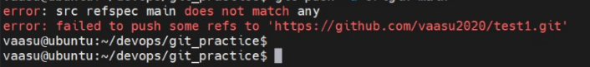
Please use the below command who are facing the errors as shown in above snippets
git remote set-url origin <use_ssh_url_from_git_remote_repo>
e.g. git remote set-url origin git@github.com:CK-Lacki1924/DevOps_B11.git
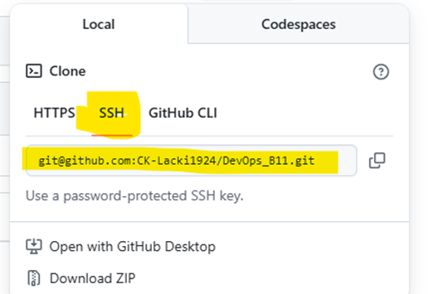
Then try to push using
git push –u origin master

Branch - A branch is a way to isolate development work on a particular aspect of a project or a seperate streamline.
Create a branch
When a branch is created, it diverges from the primary branch. It allows developers to work on a new feature or bug fix without affecting the main codebase.
To create a branch
Git branch <branch_name>
git branch devopb11

To create branch and checkout or switch to that
git checkout -b <branch_name>
git checkout -b devopsb102

To switch from one branch to another
git switch <branch_name>
git switch testing

To list the branches in local repo
git branch
git branch
devopsb11
* master

*indicates the current branch

Git pull origin <branch_name>
Git pull origin master = command to download and update the local repo with remote repo. Or to pull the changes made to a specific branch by our team mates,
Git pull lets us know what changes have made by others from team members

Git status – it shows the current status of our working directory with respect local repo. Either our files staged or moved to commit and everything is committed to local repo… these kind of info we can get with this git status

Git clone - It is used to download or copy entire remote repository to local repo …
Git clone <repo_ssh_url>
Create a new directory and do clone
Git clone git@github.com:CK-Lacki1924/DevOps_B10.git
To get url
Go to github page and in that repo homepage u can see a tab as code button in green. In the drop down choose ssh type url and add with command…
Note: Please delete the directory created after cloning the repository

Git log - is used to get the logs of commit history
Git log --oneline
1729f82 (HEAD -> master, origin/master, feature, devopsb10, dev) Adding a file
1729f82 – Commit hash

Task
1. Practice – git add, git commit, git push, git pull, Git status, git log and git clone
2. How to change the commit message?
3. How to list the remote repositories added to our local?
4. How to delete branches from local and remote?
---------------------------------------------------------------------------------------------------------------------------------------

